1.3 I can select and use website features and structures to help the user navigate round web pages with the site

When creating my website I added a navigation bar to help users navigate the website.

I used HTML as below to create the navigation bar;

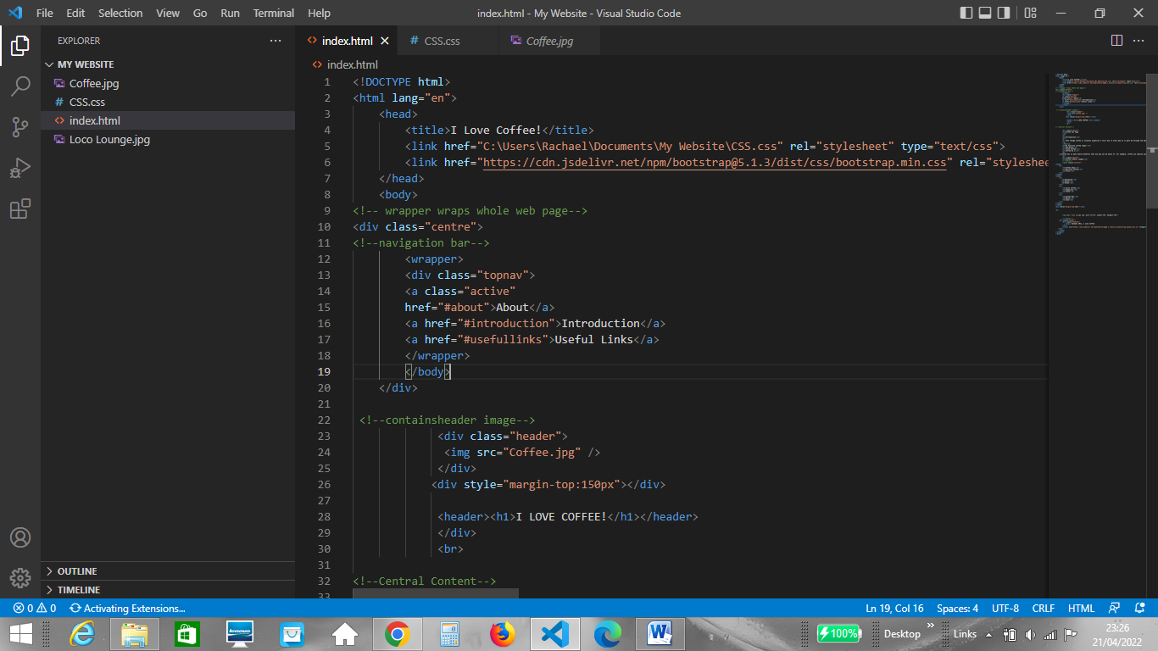

And then I styled with the following CSS to help make the navigation bar look clear to the user when using the site;

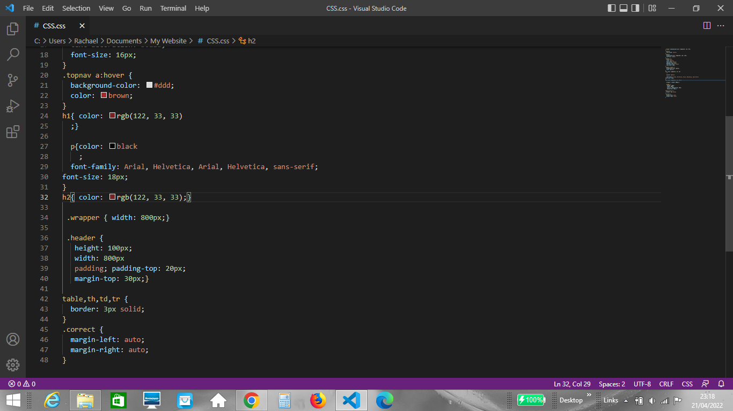

Below is an image of how the website looks once the styling is applied;

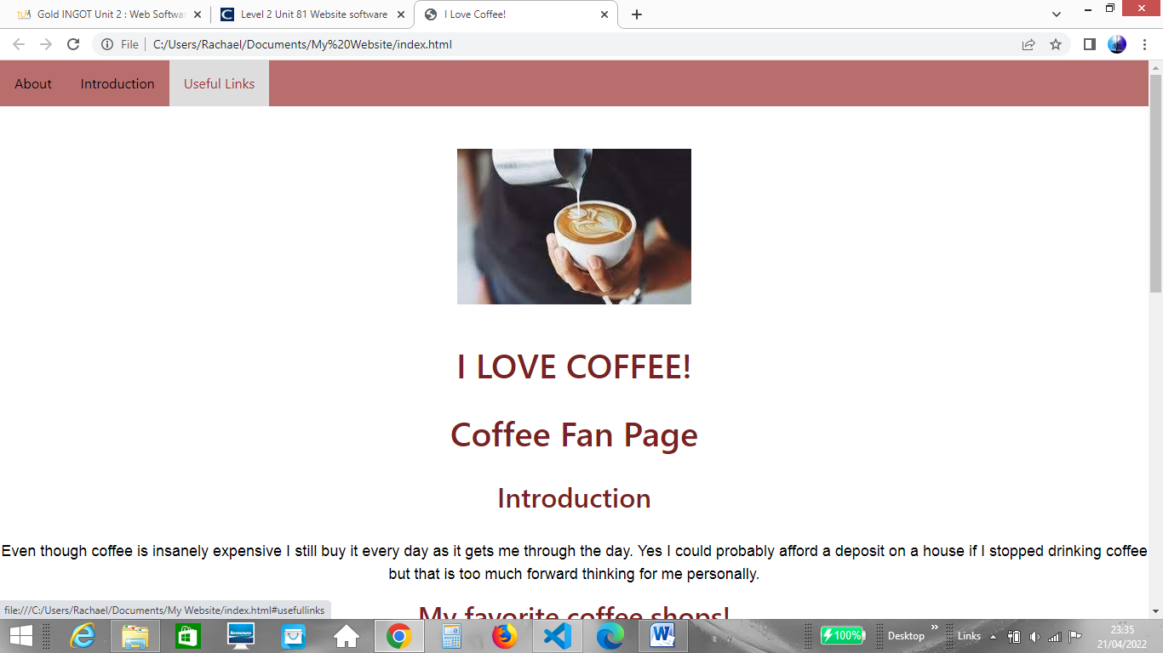

In this image the cursor is hovering over the navigation bar. The CSS styling applied means that when a link is selected on the navigation bar the link will be highlighted making it clear to the user which link they are selecting.